**Temple Inn & Suites**

Site Plan

*Mary Ann Overson | WDD230*

**Site Purpose**

The purpose of this website is to promote and provide information about the specialized services that the Temple Inn & Suites hotel chain offers in order to meet the needs of temple patrons who come to serve in the temple or those patrons who participate in events such as sealings, weddings, receptions, and youth trips. In addition to information, this site offers reservations to any number of hotel locations around the world. Because the users of this website are members of The Church of Jesus Christ of Latter-day Saints, this website will maintain the reverent and respectful nature of the temple, and convey the concept of being a haven of comfort and accessibility.

**Domain Name**

temple-inn.com

**Logo**



**Target Audience**

The typical demographic for this website is expected to be predominantly members of The Church of Jesus Christ of Latter-day Saints and people who may not be familiar with the location of the temple they choose to visit. They will be from all parts of the world, so may need special services to accommodate language and cultural differences. This demographic is likely to be family-oriented and may need assistance with elderly relatives and/or small children.

**Personas**

**Dakota Robinson**

Brother Robinson is the Branch Young Men’s Leader in Pierre, South Dakota. He and the Young Women’s President would like to arrange a youth trip to the closest temple to Pierre, SD, the Bismarck, North Dakota Temple. The 16 youth who will be going, both young men and young women, will need separate accommodations for each, in addition to the 6 adult leaders who will be accompanying them. It is a 4-hour drive from Pierre to Bismarck, so they will spend 4 days and 3 nights and plan to attend the temple twice a day to perform baptisms for the dead.

Questions Brother Robinson has:

* How many people can stay in each room?
* Is there clothing rental at the temple?
* What are the hours and what is the schedule of the Bismarck Temple?
* Is there a cafeteria?
* Is there Wi-Fi at the Temple Inn & Suite in Bismarck, ND?
* What are other activities in Bismarck is available for the youth?
* What does each youth and adult need to bring in order to make this trip as smooth as possible?

**Fabio Simas**

Brother Simas lives in Anapolis, Brazil and he, his elderly parents, his wife, and 4 children are traveling to the Sao Paulo Temple to be sealed to one another. In addition to this, his wife’s brother, who live in Belo Horizonte, is getting married in the Sao Paulo Temple which will be followed by a reception. It will take a full day to travel to Sao Paulo, so the Simas’ family will be spending 5 days and 4 nights at the Temple Inn & Suites.

Questions Brother Simas has:

* Is the hotel in walking distance to the temple and, if not, is there shuttle service available?
* What will we need to bring to make this trip successful and less stressful?
* My father is in a wheelchair – what accommodations does the hotel have for the handicapped?
* We’d all rather stay in the same room – do you have rooms available for 8 people?
* We have a baby – do you have cribs available?
* What food accommodations are available at the hotel and nearby?
* Is there a kitchenette in the room?
* Is there clothing rental available at the temple?
* How far in advance do I need to make reservations?

**Site Map**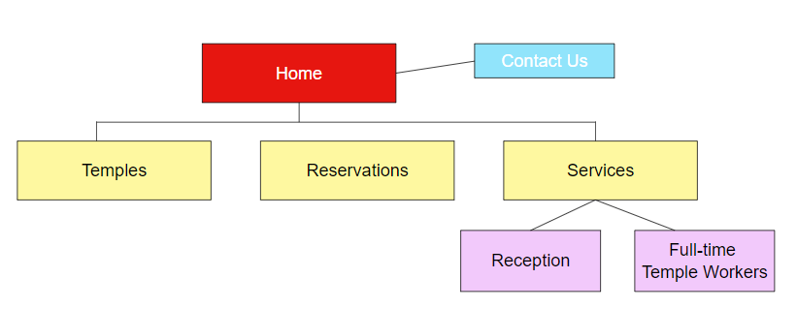

**Color Scheme**

|  |  |  |  |  |
| --- | --- | --- | --- | --- |
| **Primary** | **Secondary** | **Accent 1** | **Accent 2** | **Accent 3** |
| # 0b4665 | # ec9a17 | #9aB05e | #669bbc | #780000 |

**Typography**

|  |  |  |  |  |
| --- | --- | --- | --- | --- |
| Site header | Noto Serif Display | 40px | # 0b4665 | Sample |
| Primary Navigation | Noto Serif Display | 30px | # ec9a17 | **Sample** |
| Footer Navigation | Noto Serif Display | 20px | #9aB05e | **Sample** |
| Heading 1 (h1) | Noto Serif Display | 30px | # 0b4665 | **Sample** |
| Heading 2 (h2) | Noto Serif Display | 25px | # ec9a17 | **Sample** |
| Heading 3 (h3) | Noto Serif Display | 20px | #9aB05e | **Sample** |
| Paragraph text (p) | Nanum Gothic | 16px | #780000 | **Sample** |

**Wireframe – Home Page**

**Small View**

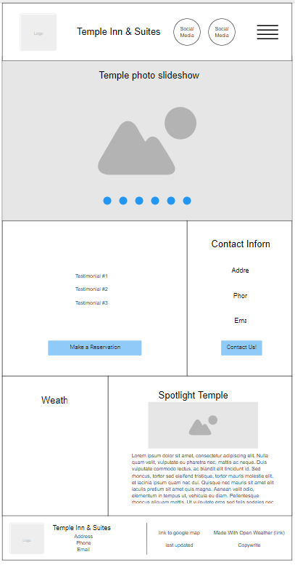

**Medium View**

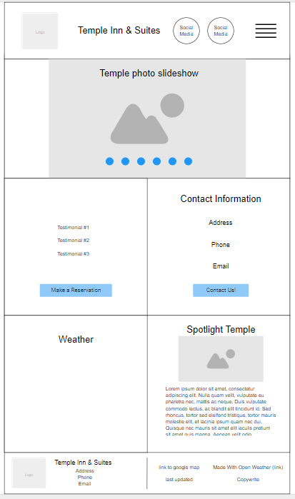

**Large View**

